5.8 Stokes’ Theorem

Definition: Suppose that is a vector field on and the partial derivatives of the components of F exist. The curl of F is the vector field on defined by .

Remark: To help ourselves in remembering the formula for curl, we may write , since

Example 1: Find the curl of the vector field: .

We calculate that

Example 2: Suppose that is a function of three variables that has continuous second-order partial derivatives. Find a formula for .

We have that . This means that Since has continuous second-order partial derivatives we know . So, .

The above example leads to the following result.
Theorem: If the vector field is conservative and P, Q, and R have continuous first-order partial derivatives, then .

Example 3: Show that the vector field is not conservative.

We know that the first-order partial derivatives of the component functions of F are continuous. We note that . So, by the above theorem we know that F is not conservative.

Theorem: If F is a vector field defined on all of whose component functions have continuous partial derivatives and , then F is a conservative vector field.

Example 4: Consider the vector field: .
- Show that F is a conservative vector field.

We note that the component functions of F have continuous partial derivatives on all of . We compute: . So, by the most recent theorem, we know that F is a conservative vector field.

- Find a potential function for F.

There are general procedural methods developed in 5.3 which could be used here, however it is likely that guess and check is much faster for this particular example. In particular, a potential function for F is .

Application: Suppose that F represents the velocity field in fluid flow. Particles near in the fluid tend to rotate about the axis that points in the direction of , and the length of this curl vector is a measure of how quickly the particles move around the axis. If at a point P we say that the fluid is free from rotations at P (i.e. there is no whirlpool or eddy at P) and F is called irrotational at P.
Recall: We had two ideas for how to generalize Green’s Theorem:

- We might try to increase the “dimensions of the integrals” in Green’s Theorem by one. More precisely, we might guess that the flux of a vector field through a closed surface is equal to a triple integral taken over the region enclosed by the surface.

- Alternatively, if we have a closed curve in 3-space (rather than 2-space), we might guess that the line integral of a vector field over the curve is equal to a surface integral taken over the region that the curve encloses.

In this section we purse the second of these ideas. However, before stating Stokes’ Theorem, we need a definition.

Definition: Suppose that curve C is the boundary curve of some surface in . Suppose that the unit normal vector n determines an orientation for . The orientation of induces the positive orientation of C in the following sense. If one walks around C with his or her head in the direction of n and is always on the left, then one is following the positive orientation of C.

Note: There is a nice illustration of this definition on page 1134 of the textbook.

Theorem (Stokes’ Theorem):
Let be an oriented piecewise-smooth surface that is bounded by a simple, closed piecewise-smooth boundary curve C with positive orientation. Let F be a vector field whose components have continuous partial derivatives on an open region in that contains . Then, .
Proof: (NOT DONE IN CLASS)
(in the case that is given by where , has upward orientation, and g has continuous second –order partial derivatives and D is a simple plane region):

To make things in the proof easier to discuss, we draw a picture and introduce some notation.
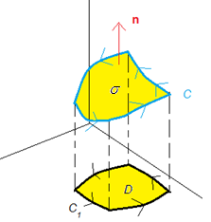
We let where P, Q, and R are functions of x, y, and z. We let correspond to the projection of C onto the xy-plane. Notice that D is the projection of onto the xy-plane and C is D’s boundary curve. Notice also that the upward orientation of makes it so that will have positive orientation.
We know that . Then, by a formula from section 5.6,

We will show that is equal to this final expression. Suppose that where is a parameterization of the curve . Then, a parameterization for C is: where .
Now, we know that As we proceed it is important to note that, in this integral, x and y are functions of t. Also, z is a function of x and y which are in turn functions of t since . So, we will use the chain rule many times as we simplify the line integral. Specifically,
Now, we can apply Green’s Theorem! In particular,
Note: For the final step it is useful to keep in mind the finite rooted trees for P, Q, and R:
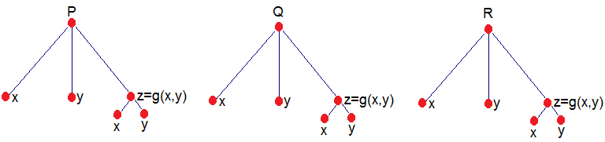

Note: The divergence theorem says the flux of F across the boundary of G is a triple integral over G. Notice the theme in Green’s Theorem, The Divergence Theorem and Stokes’ Theorem: some integral over a region is equal to another integral taken over the boundary of the region. This is similar to the way in which the Fundamental Theorem of Calculus was able to help find the area of region beneath a function by looking at the value of a different function at the endpoints.

We now show some applications of Stokes’ Theorem.

Example 5: Suppose that C is the triangle which is traced by moving from (0,0,1) to (1,0,0) to (0,1,0) to (0,0,1). Use Stokes’ Theorem to find the exact value of the work done by the force field in moving a particle around the curve C.

We know . With the intent of using Stokes’ Theorem, we begin by drawing a picture of the curve C and the surface, , that it encloses. The surface is in blue in the picture below.
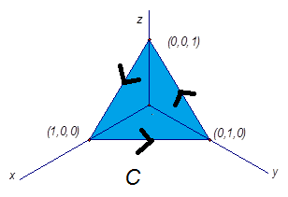
We see from the picture that is a portion of the plane given by with upward orientation. In order to determine the x and y values that yield , we project the surface onto the xy-plane. We get:

We see that . So, the surface is given by where . Since the hypotheses of Stokes’ Theorem are met, we know that . So, we compute: . We also see that if then Therefore,
Notice we used the area formula for a triangle to compute the integral above.

Note: We could do this example using the ideas of section 5.2, but this would be much less elegant as we would need to find 3 different parameterizations.

Example 6: Suppose that . Suppose that is the hemisphere given by where , oriented in the direction of the positive y-axis. Find the exact value of .

We begin by drawing a picture of the surface and we indicate the orientation in our picture.
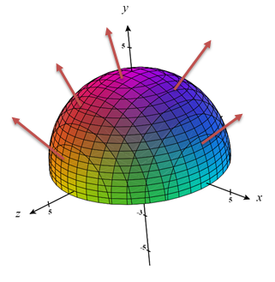

We see that the boundary curve, C, for this surface is in the xz-plane and has equation: . A picture of C with positive orientation is below (Note: in the picture below the positive y-axis points into the page).

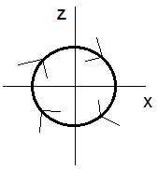

A parameterization of C is where .
Since the hypotheses of Stokes’ Theorem are satisfied, we have that:

Example 7: Suppose is a sphere centered at the origin with positive orientation and F satisfies the hypotheses of Stokes’ Theorem.

- Is there a boundary curve of ?

No, there is no boundary curve of . An intuitive reason for this is that locally every point on the sphere is the same. There is no point that we would want to say is on the boundary curve.

- Find

Since there is no boundary curve of we cannot directly apply Stokes’ Theorem. So, we split up the surface into its “top half”, , and its “bottom half” . Then, we have that .
Crucially, following the idea of the most recent example, we have that both and have a boundary curve. The boundary curve for both surfaces is a circle in the xy-plane centered at the origin with radius the same as .

However, the orientation of the boundary curve for is counterclockwise, and the orientation for is clockwise. So, if the boundary curve for is C, then the boundary curve for is . So, by Stokes’ Theorem, we have that

Example 8: Suppose F is a vector field whose components have continuous partials on all of three space. Suppose is a surface that is bounded by the curve C such that and C satisfy the hypotheses of Stokes’ Theorem. Suppose that is a surface that is bounded by the curve –C such that and –C satisfy the hypotheses of Stokes’ Theorem. If , then what is the value of ?

By Stokes’ Theorem, we have that . Thus,

Note: This example implies something very important. The surfaces of were irrelevant to the calculations here except for the fact that they had the same boundary curve! This means that surfaces which have the same boundary curve (with the same orientation) will always produce the same flux according to Stokes’ Theorem. This is amazing since it can allow us to freely change the surface, we are using to one that is easier to work with as long as it has the same boundary curve as the original!
Example 9: Suppose that is a surface in the xy-plane with upward orientation. Suppose that C is the boundary of . Suppose C and satisfy the hypotheses of Stokes’ Theorem. Suppose that F is a vector field given by where F satisfies the hypotheses of Stokes’ Theorem. Use Stokes’ Theorem to find a formula for .

Clearly the surface is given by where . Let . Note that geometrically and D look the same (the only difference is is a subset of and D is a subset of ).

By Stokes’ Theorem, we know that . So, we compute that . We also see that if then . Therefore,

Note: We have obtained Green’s Theorem from Stokes’ Theorem in this example which is in line with our intuition that Stokes’ Theorem is a generalization of Green’s Theorem!

